**Project documentation**

**Subject: Web based programming**

**Subject code: CS-114**

# **Project Name**

Website for LED manufacturing factory

# **Introduction**

Website is a powerful marketing tool. A well-maintained website can help one gain a competitive advantage in the industry and improve one’s business image. Developing a website offers many benefits including helping the owner get more leads and prospects, increase sales, enhance the professional brand and improve the customer service. However according to various recent studies, just about 35% – 40% of all small businesses don’t have websites. Following are some real time advantages of having a website for any scale of business for present profit and future growth:

* Improve advertising effectiveness
* Save money on advertising through printing
* Easy access to new customers
* Easy to use and update
* Improve productivity by spreading customer awareness
* Expand market
* Promotion of products and services
* Building reputation
* Proper platform of communication

Hence the aim of the undertaken project is to build a website for the LED manufacturing factory named AP Electronics so that it helps in the business expansion of the factory. The objective of the project has been discussed in the following section.

# **Motivation**

The motivation has been sought from already existing websites working on this domain such as India Bulls LED. The web address of the mentioned organisation is given as follows: <https://www.indiabullsled.com/>

# **challenge**

The primary challenges faced are as follows:

* **Front-end design:** To design an interactive and responsive front end and interface.
* **Back-end development:** To build a normalised database for storing records of daily business.
* **Linking:** To connect the back end to the front end interface and ensure data flow from/to the database.

# **Application**

Once the website is designed it can be used to fulfil a few objectives discussed in the next section.

Having an overview, it can be said that the website can be used for online marketing of products and business.

# **Objectives**

The objective of the project is to develop a website for an LED light manufacturing factory named AP Electronics. The services to be provided through the website are as follows:

1. **Marketing:** To draw the attention of netizens and distant retailers to customised products and accept online orders depending on the acceptability of terms and conditions of business.
2. **Sales:** To ensure supply of conventional products in order to meet the market demand through business on an online platform.
3. **Customer satisfaction:** To ensure customer satisfaction and fulfilment of the market needs by delivering good quality products.

# **Modules-methodology of implementation**

Modular technique of web development breaks down complex problems into smaller components that are easier to understand, communicate and build. The modules to be implemented are as follows:

1. **Home Page:** Home page that is to act as a welcome page for visitors and provide easy access to other web pages.
2. **Personal space:** To provide services related to indoor and outdoor lighting at home space.
3. **Professional space:** To provide services related to lighting of commercial spaces like office, shop, industry or community hall.
4. **Contact us:** Provide basic information about the company.
5. **Database:** Associate database to keep records of information.
6. **Payment:** To provide facilities for online payment.

The above modules need to be fully implemented and integrated to make the project complete. The methodology of implementation includes implementing the above modules.

|  |  |
| --- | --- |
| Software | Minimum requirements |
| Operating system | Windows Server 2012 R2 or above |
| IIS (Internet Information Services) | Version 8 or higher |
| Microsoft .Net Framework v4.6.1 (or higher) | Requires the machine that IIS is running on to have the Microsoft .NET v4.6.1 (or higher) Framework installed as well as the ASP.Net 4.5 and .Net Extensibility 4.5 features enabled. |

# **Hardware and Software requirements**

|  |  |
| --- | --- |
| Hardware | Minimum requirements |
| Computer | At least 2 GHz multicore processor and 10 GB hard disk space |
| RAM | At least 4 GB |

Tables- 1.1 and 1.2

# **Browser compatibility**

1. Microsoft Internet Explorer (IE) v11 or later
2. Microsoft Edge
3. Firefox v48 or later
4. Google chrome v58 or later

# **WiREFRAMES**

The wireframes for the following modules have been provided as follows:

## **HOME PAGE**

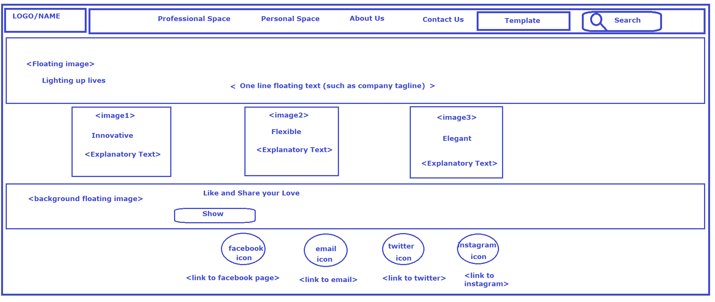

Figure-1

## **PROFESSIONAL SPACE**

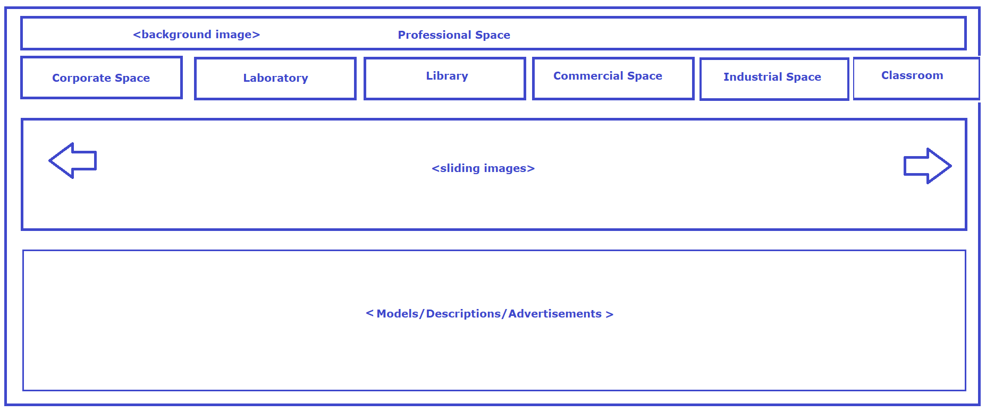

Figure-2

## **PERSONAL SPACE**

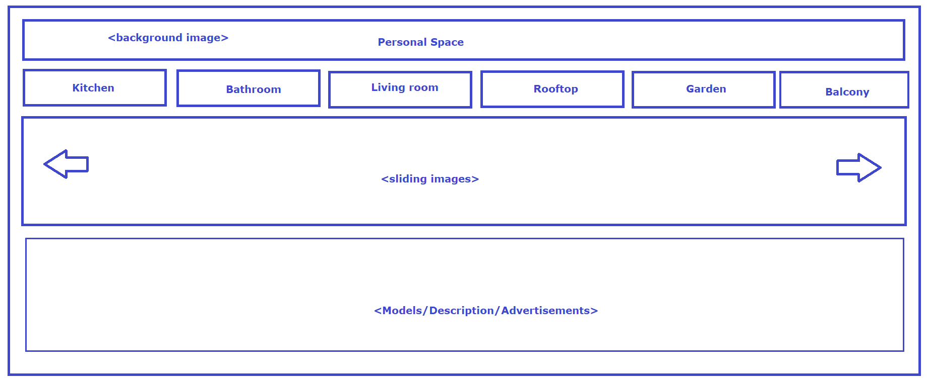

Figure-3

## **LOG IN PAGE**

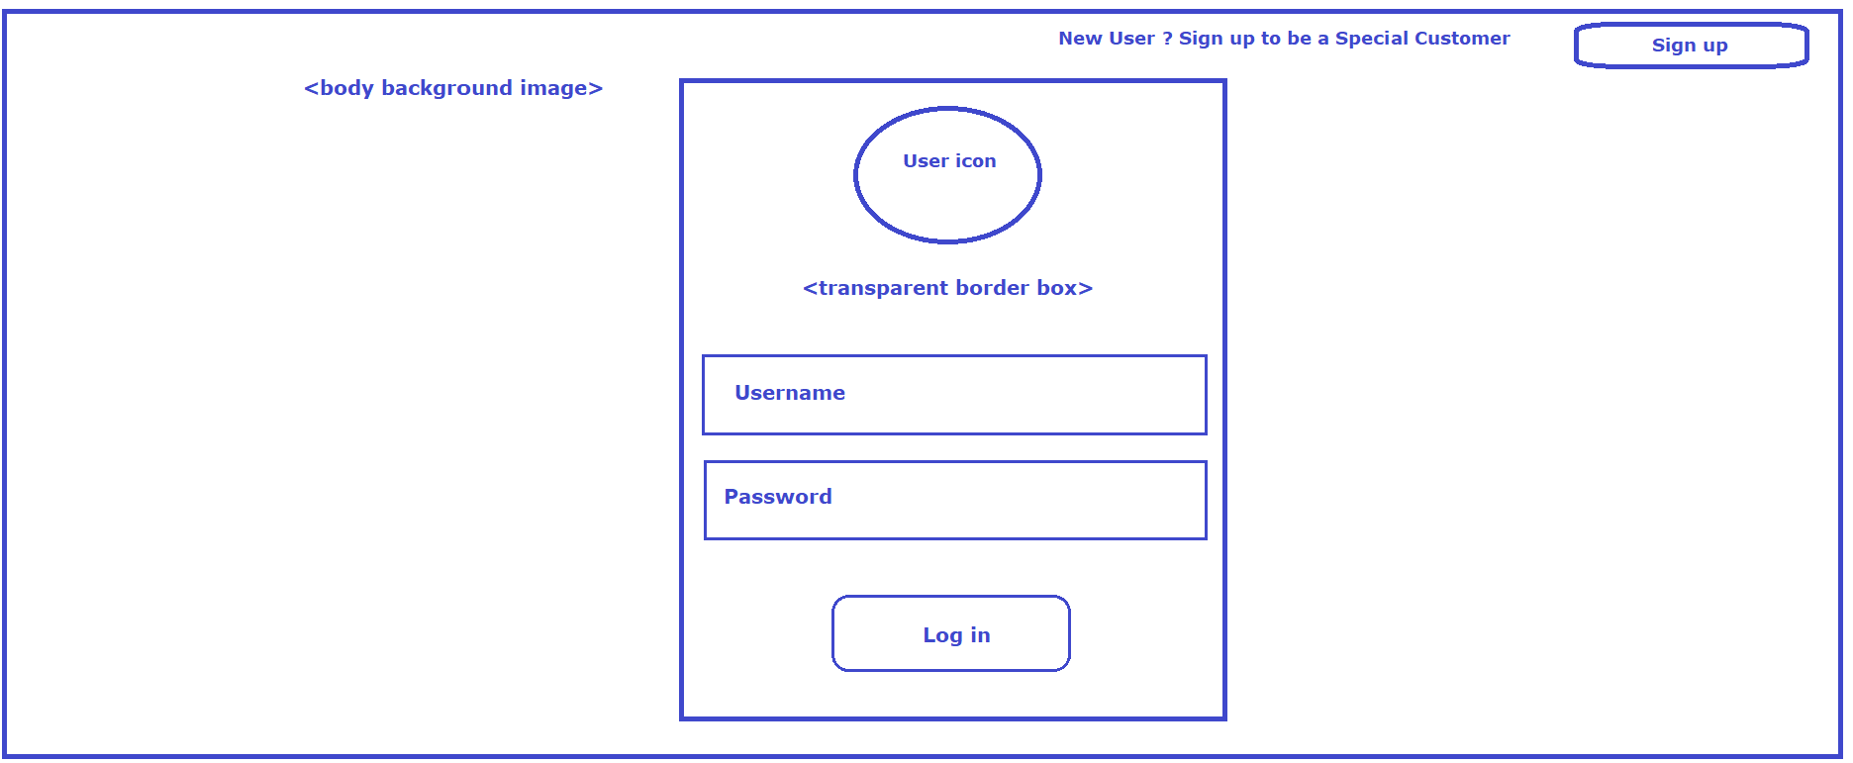

Figure-4

## **SIGN UP PAGE**

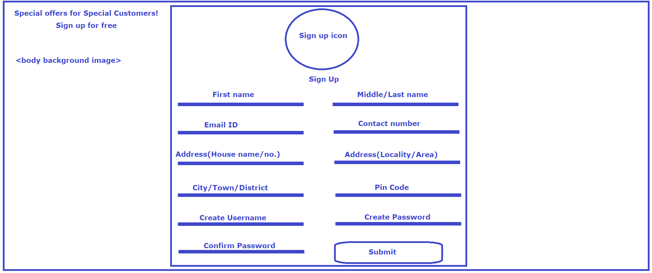

Figure-5

## **PAYMENT PAGE**

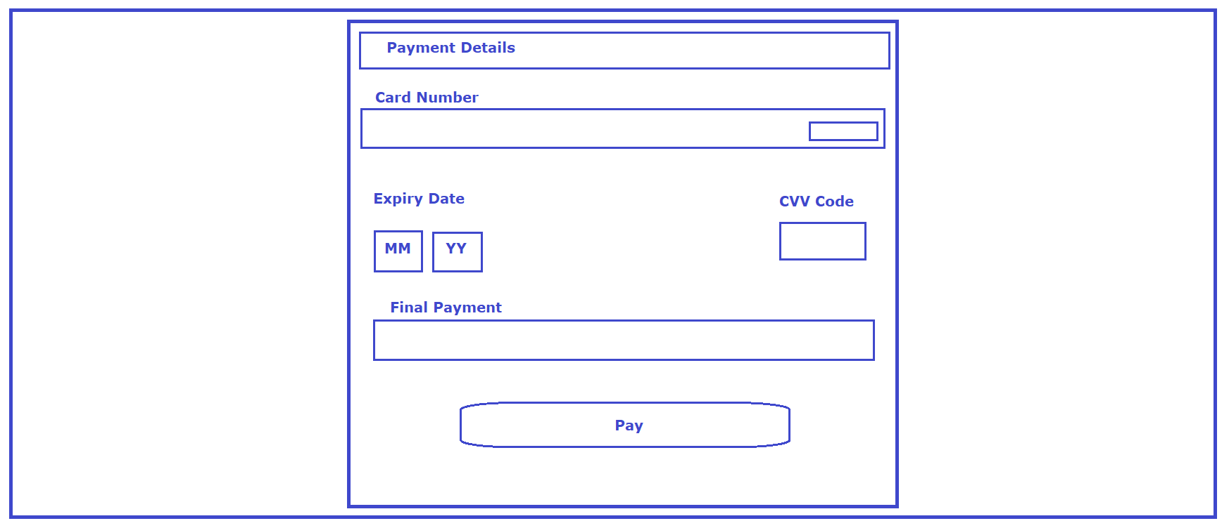

Figure-6

# **front end development**

Front-end web development, also known as client-side development is the practice of producing HTML, CSS and JavaScript for a website or Web Application so that a user can see and interact with them directly. The challenge associated with front end development is that the tools and techniques used to create the front end of a website change constantly and so the developer needs to constantly be aware of how the field is developing.

Front end developers need to ensure that their site comes up correctly in different browsers (cross-browser), different operating systems (cross-platform) and different devices (cross-device), which requires careful planning on the side of the developer.

A front-end developer architects and develops websites and applications using web technologies (i.e., [HTML](https://developer.mozilla.org/en-US/docs/Web/HTML), [CSS](https://developer.mozilla.org/en-US/docs/Web/CSS), [DOM](https://developer.mozilla.org/en-US/docs/Web/API/Document_Object_Model), and [JavaScript](https://developer.mozilla.org/en-US/docs/Web/JavaScript)), which run on the [Open Web Platform](https://en.wikipedia.org/wiki/Open_Web_Platform) or act as compilation input for non-web platform environments. The front-end development of the modules of **Home Page, Personal Space** and **Professional Space** have been completed so far and is discussed in the following section along with the associated screenshots.

## **Home Page**

The Home Page is the starting page of the website. All other webpages are connected to the Home Page. The **Home Page** is used to facilitate navigation to other **pages** on the **site** by providing links to prioritized and recent articles and **pages**, and possibly a search box. Browsers typically provide the option to change this page, as well as the option to open multiple pages in different [tabs](https://en.wikipedia.org/wiki/Tab_(GUI)). The Home Page of this project is the most important module because:

* It provides access to the other modules.
* It displays necessary information about the company.
* It contains navigation tabs redirected to various templates.
* It attracts the attention of netizens and helps in business promotion.

The following screenshots help to understand the different contents of the **Home Page** of the website for **AP Electronics**.

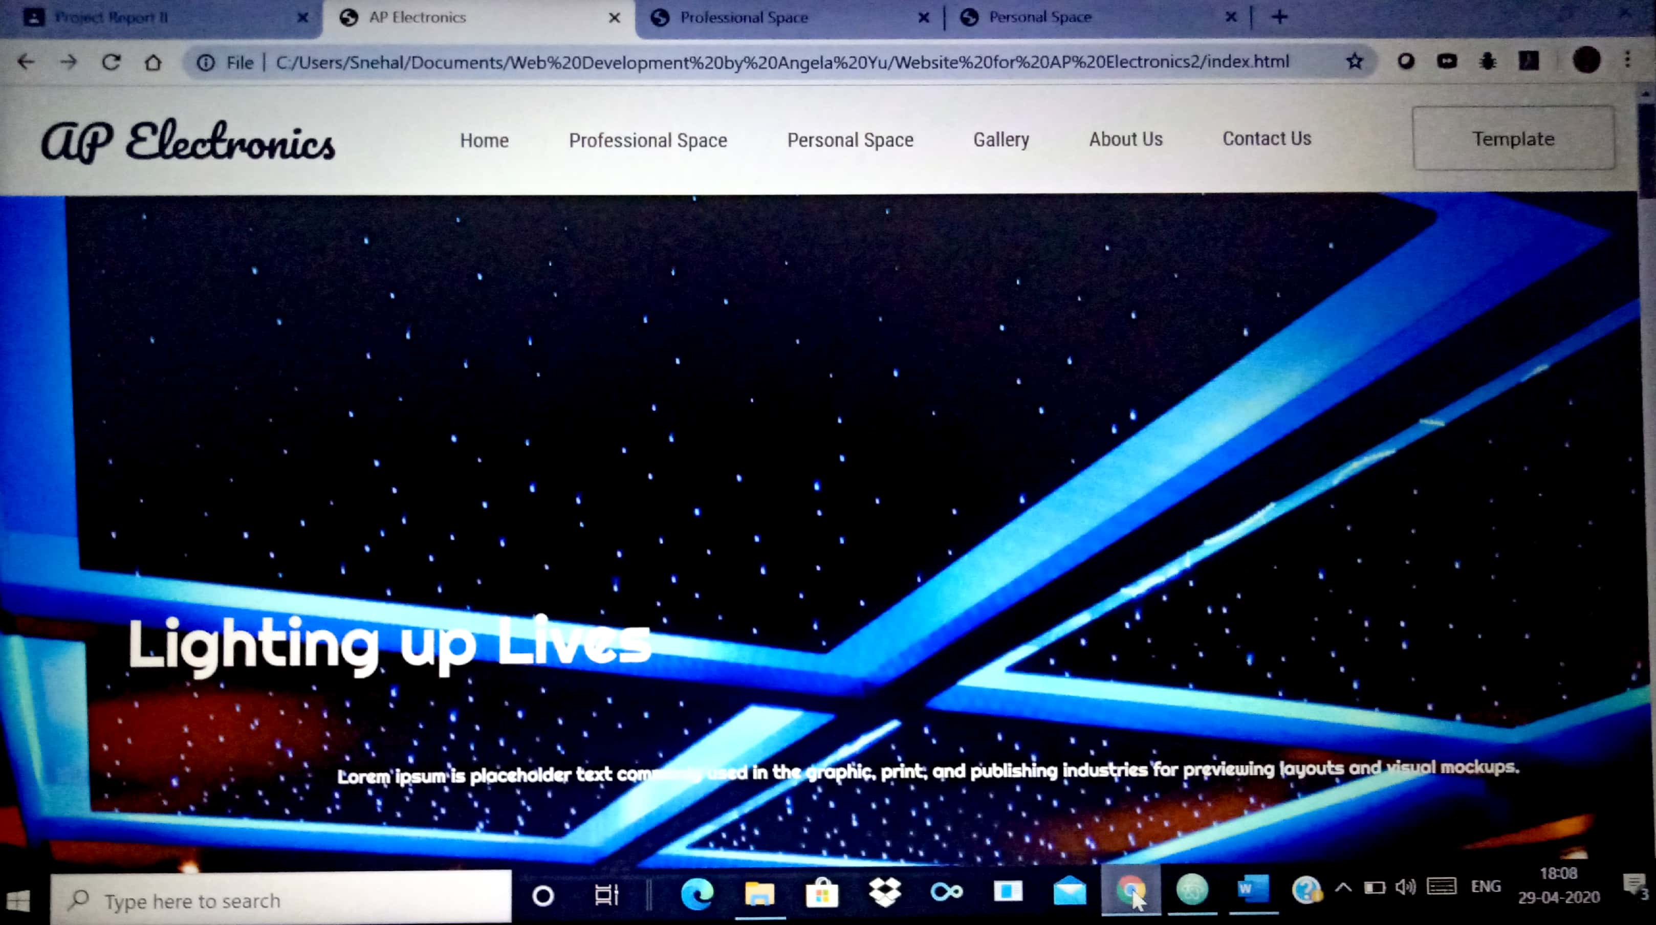

Image-1: Home Page screenshot 1

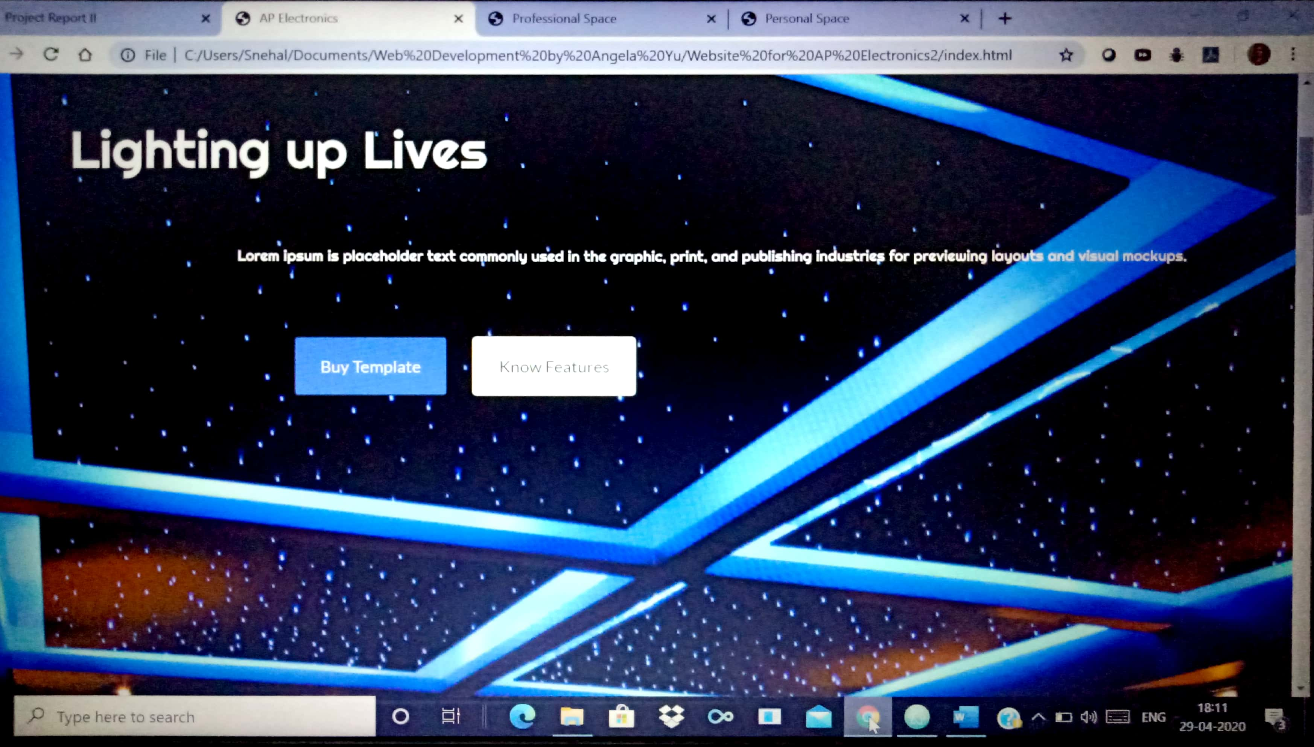

Image-2: Home Page screenshot 2

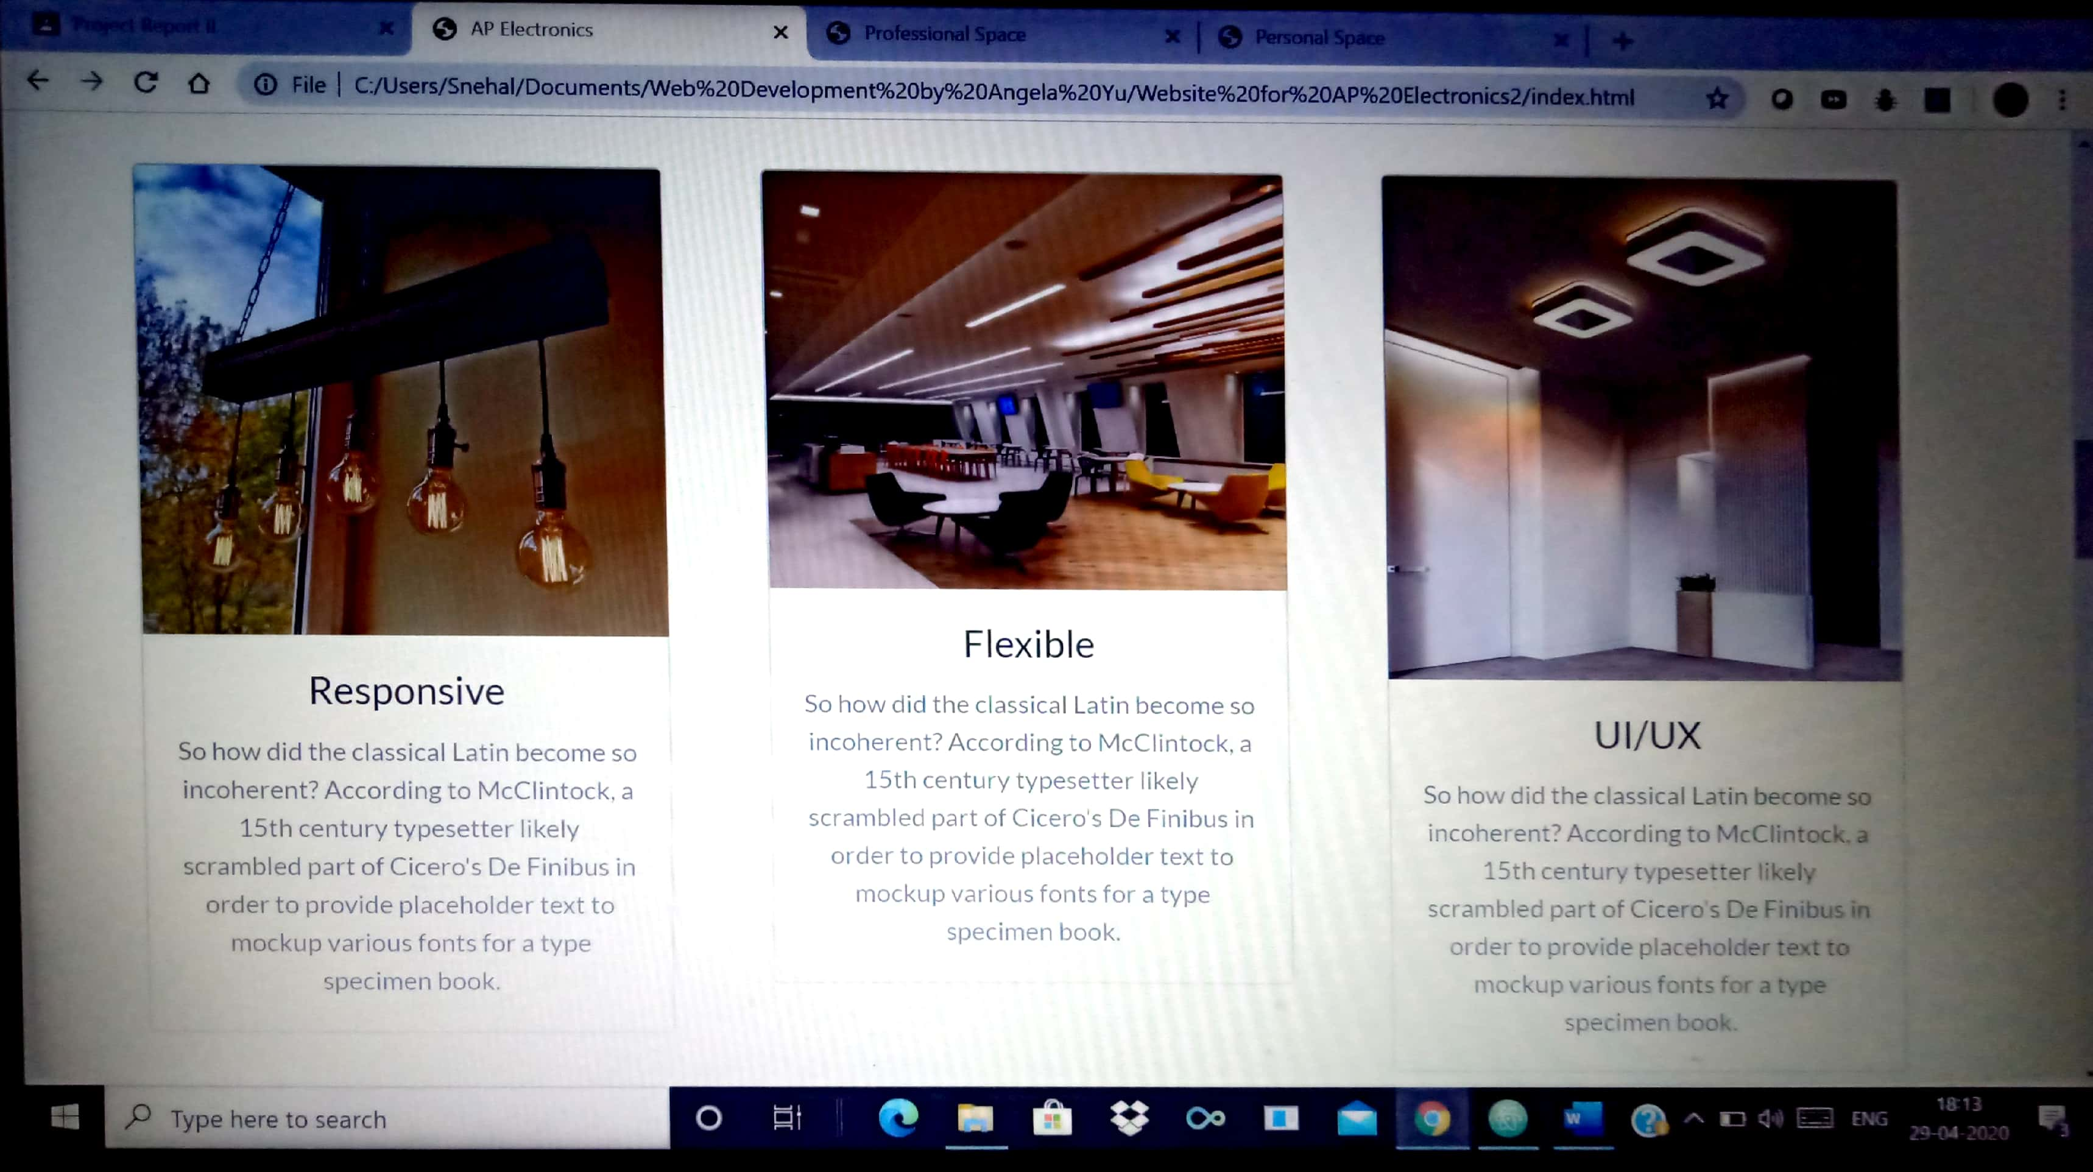

Image-3: Home Page screenshot 3

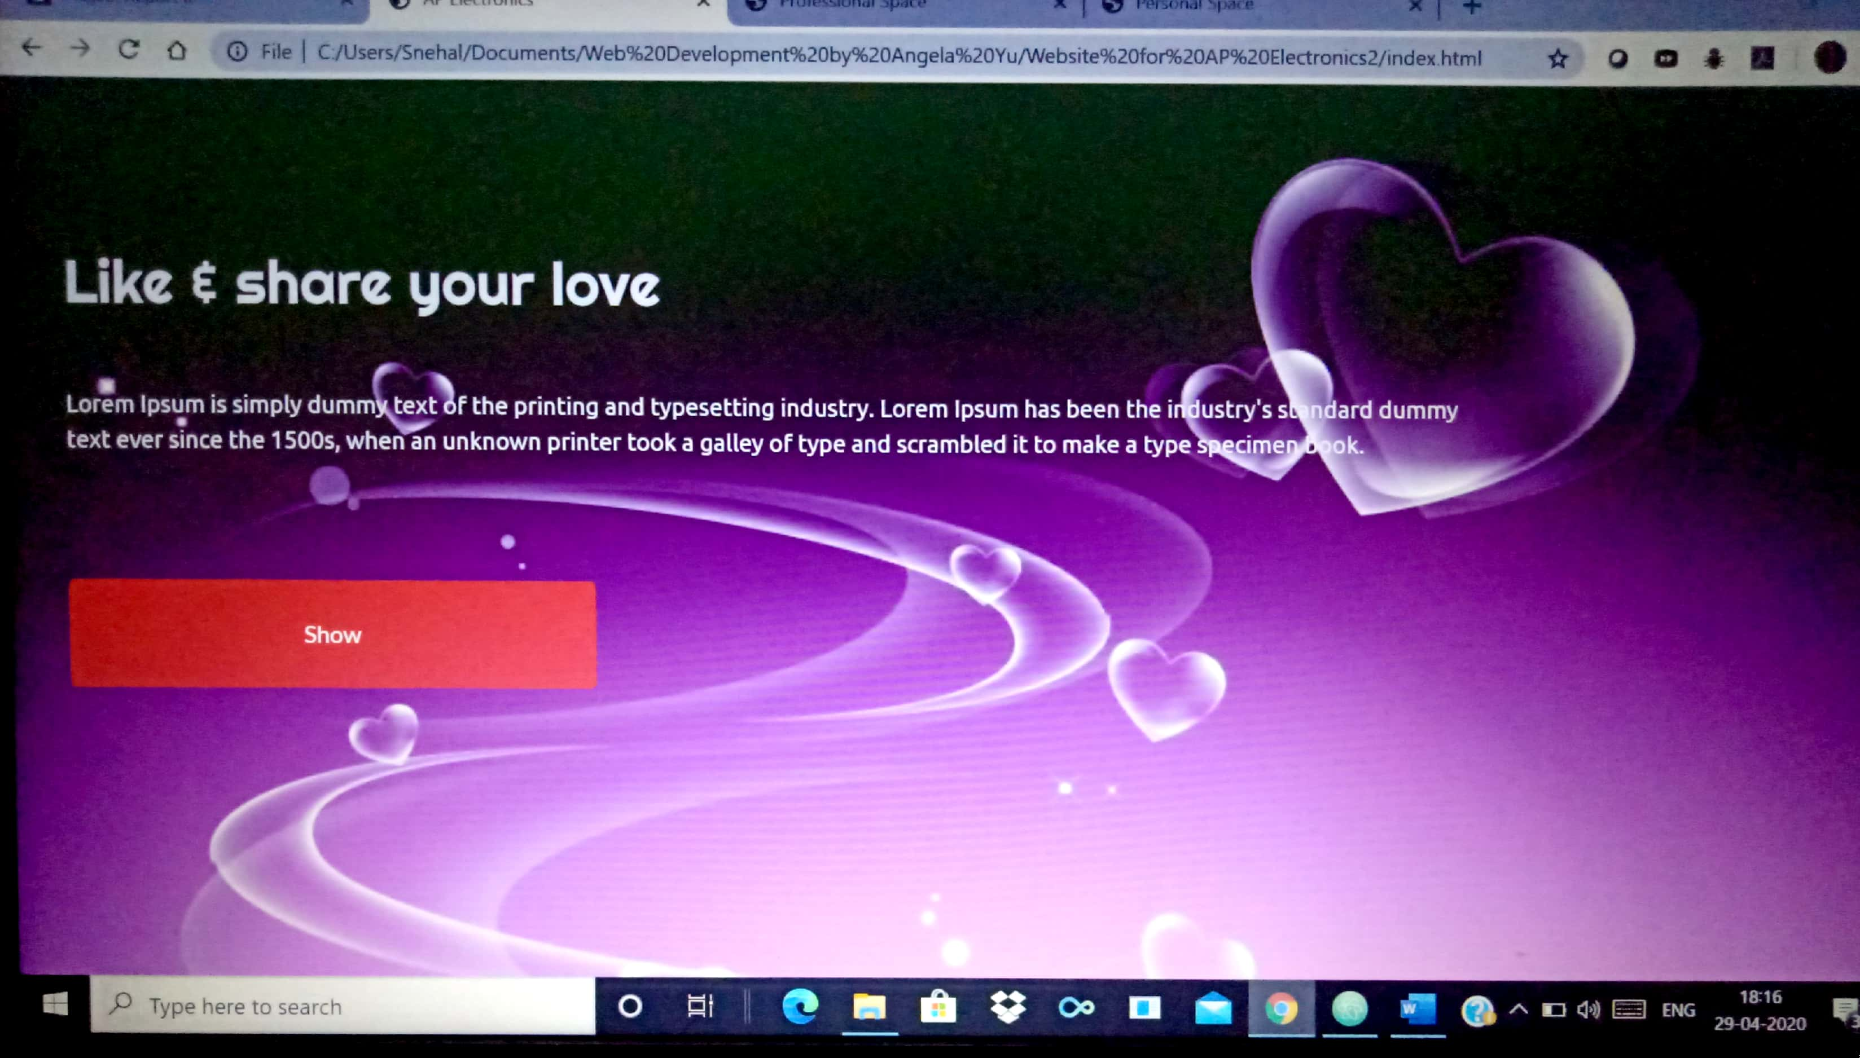

Image-4: Home Page screenshot 4

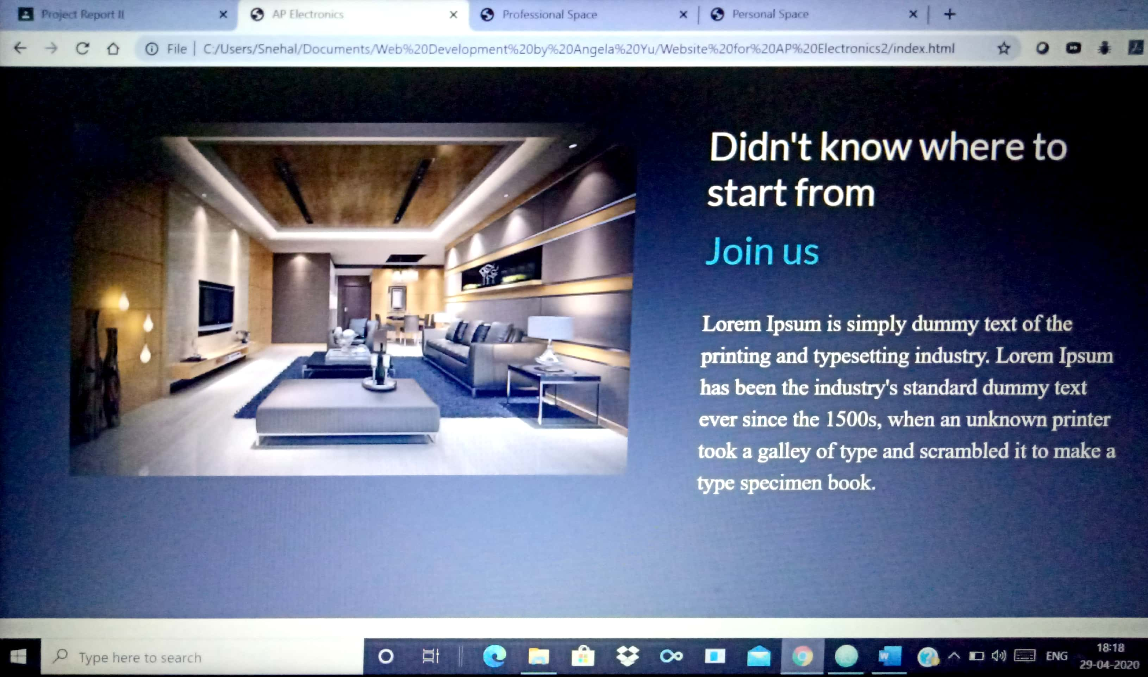

Image-5: Home Page screenshot 5

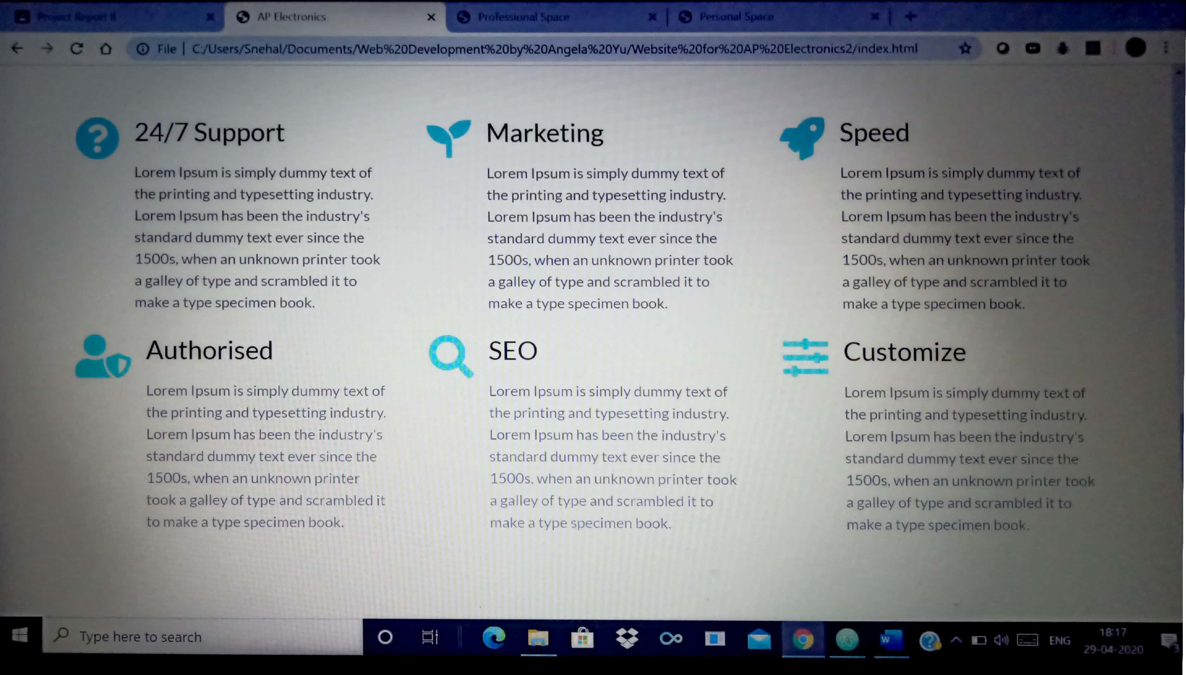

Image-6: Home Page screenshot 6

## **Personal Space**

The module of **Personal Space** contains all necessary information and images related to designs of lighting systems related to personal space. It contains 6 tabs: **Kitchen, Bathroom, Living Room, Terrace, Garden** and **Balcony**. Each of these tabs redirects to a new webpage that contains images of model designs pertaining to that particular domain. For example, by clicking on the **Kitchen** tab the user gets redirected to a new webpage where the user can go through several model designs related to Kitchen lighting. This webpage also contains a carousel of model design images to draw the attention and interest of netizens.

The **functionalities** of this **module** are as follows:

* Draw the attention of users to models related to personal space lighting.
* Provide access to tabs specific to lighting models of personal space.
* Contains testimonials of customised products.
* Helps in marketing of home lighting products of the company.

The following screenshots help to understand the different contents of the **Personal Space** module of the website for **AP Electronics**.

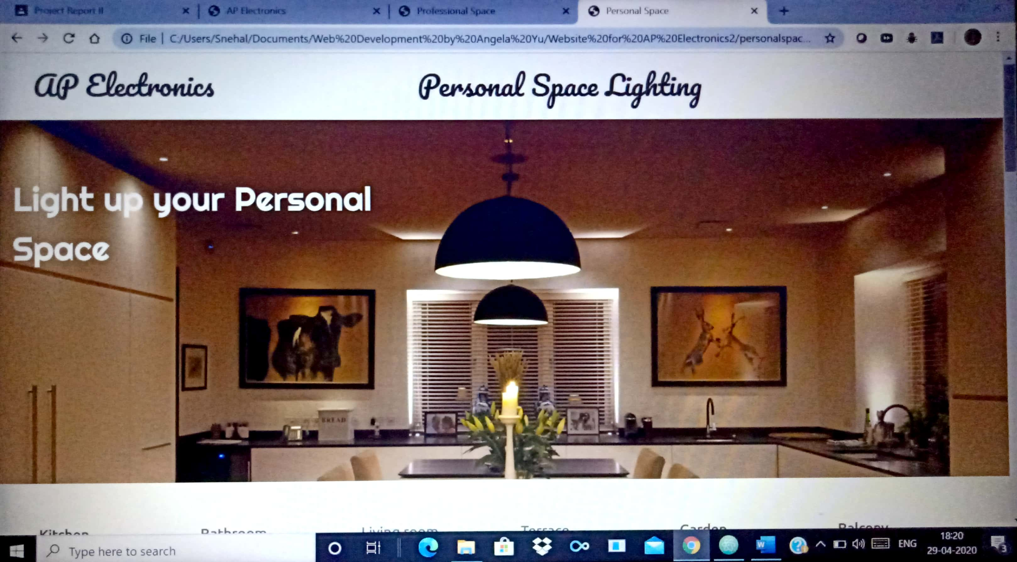

Image-7: Personal Space screenshot 1

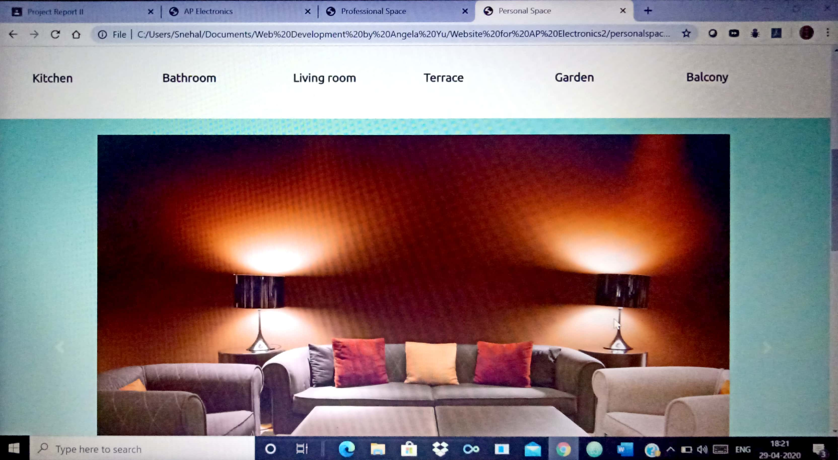

Image-8: Personal Space screenshot 2

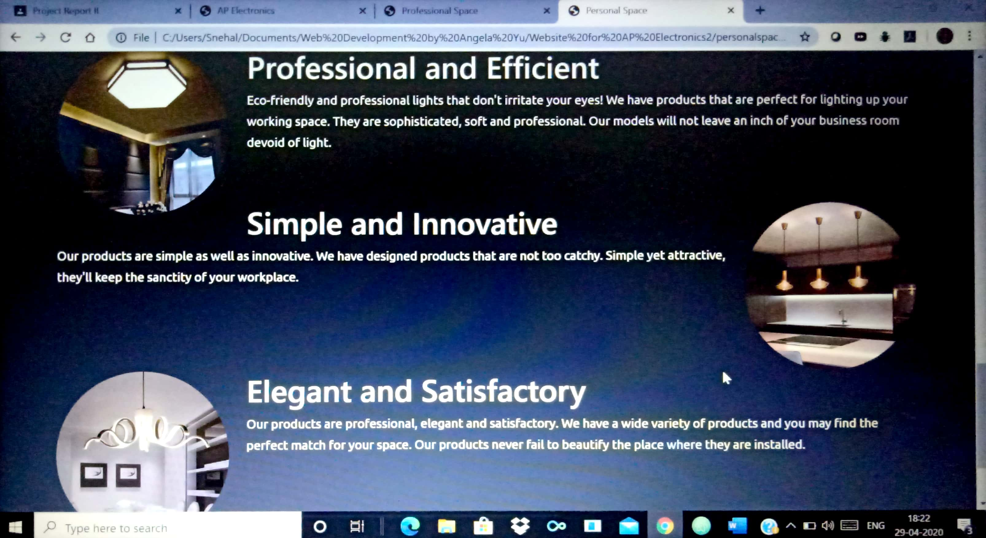

Image-9: Personal Space screenshot 3

## **Professional Space**

The module of **Professional Space** contains all necessary information and images related to designs of lighting systems related to a professional space. It contains 6 tabs: **Corporate Space, Laboratory, Library, Commercial Space, Industrial Space** and **Classroom**. Each of these tabs redirects to a new webpage that contains images of model designs pertaining to that particular domain of professional lighting. For example, by clicking on the **Laboratory** tab the user gets redirected to a new webpage where the user can go through several model designs related to laboratory lighting. This webpage also contains a carousel of model design images to draw the attention and interest of netizens to lighting models related to commercial or other professional spaces.

The **functionalities** of this **module** are as follows:

* Draw the attention of users to professional space lighting models.
* Provide access to tabs specific to lighting models of professional space.
* Contains testimonials of commercial products.
* Helps in marketing of commercial lighting products of the company.

The following screenshots help to understand the different contents of the **Professional Space** module of the website for **AP Electronics**.

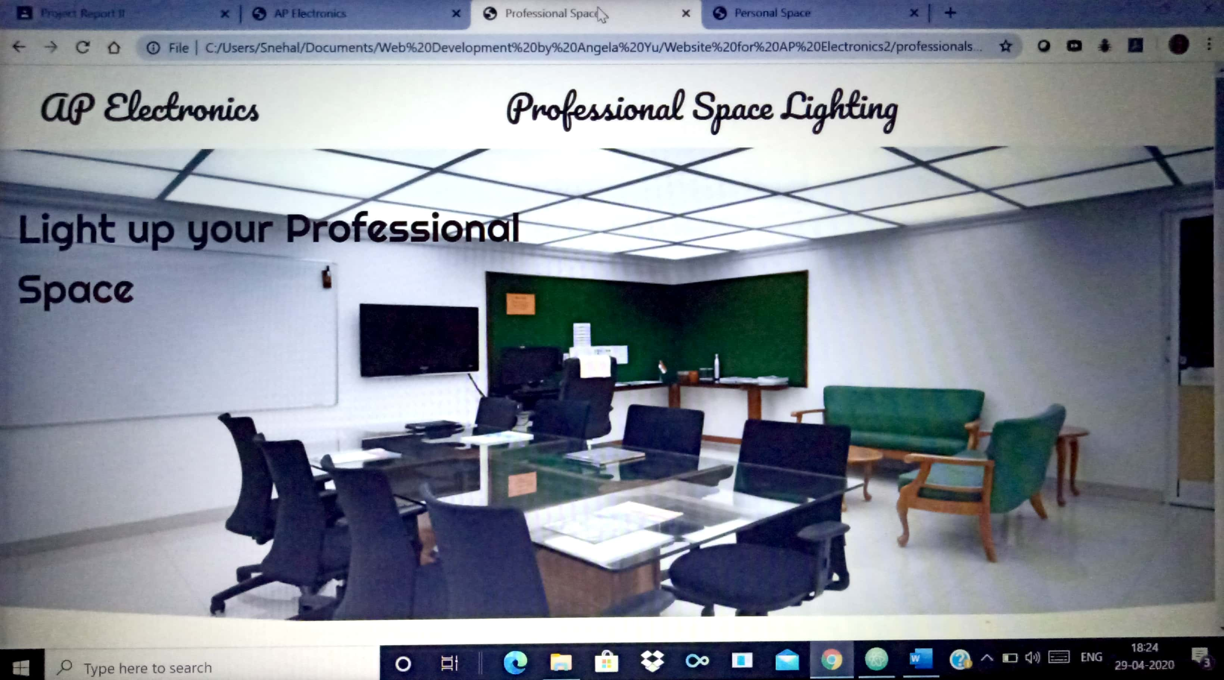

Image-10: Professional Space screenshot 1

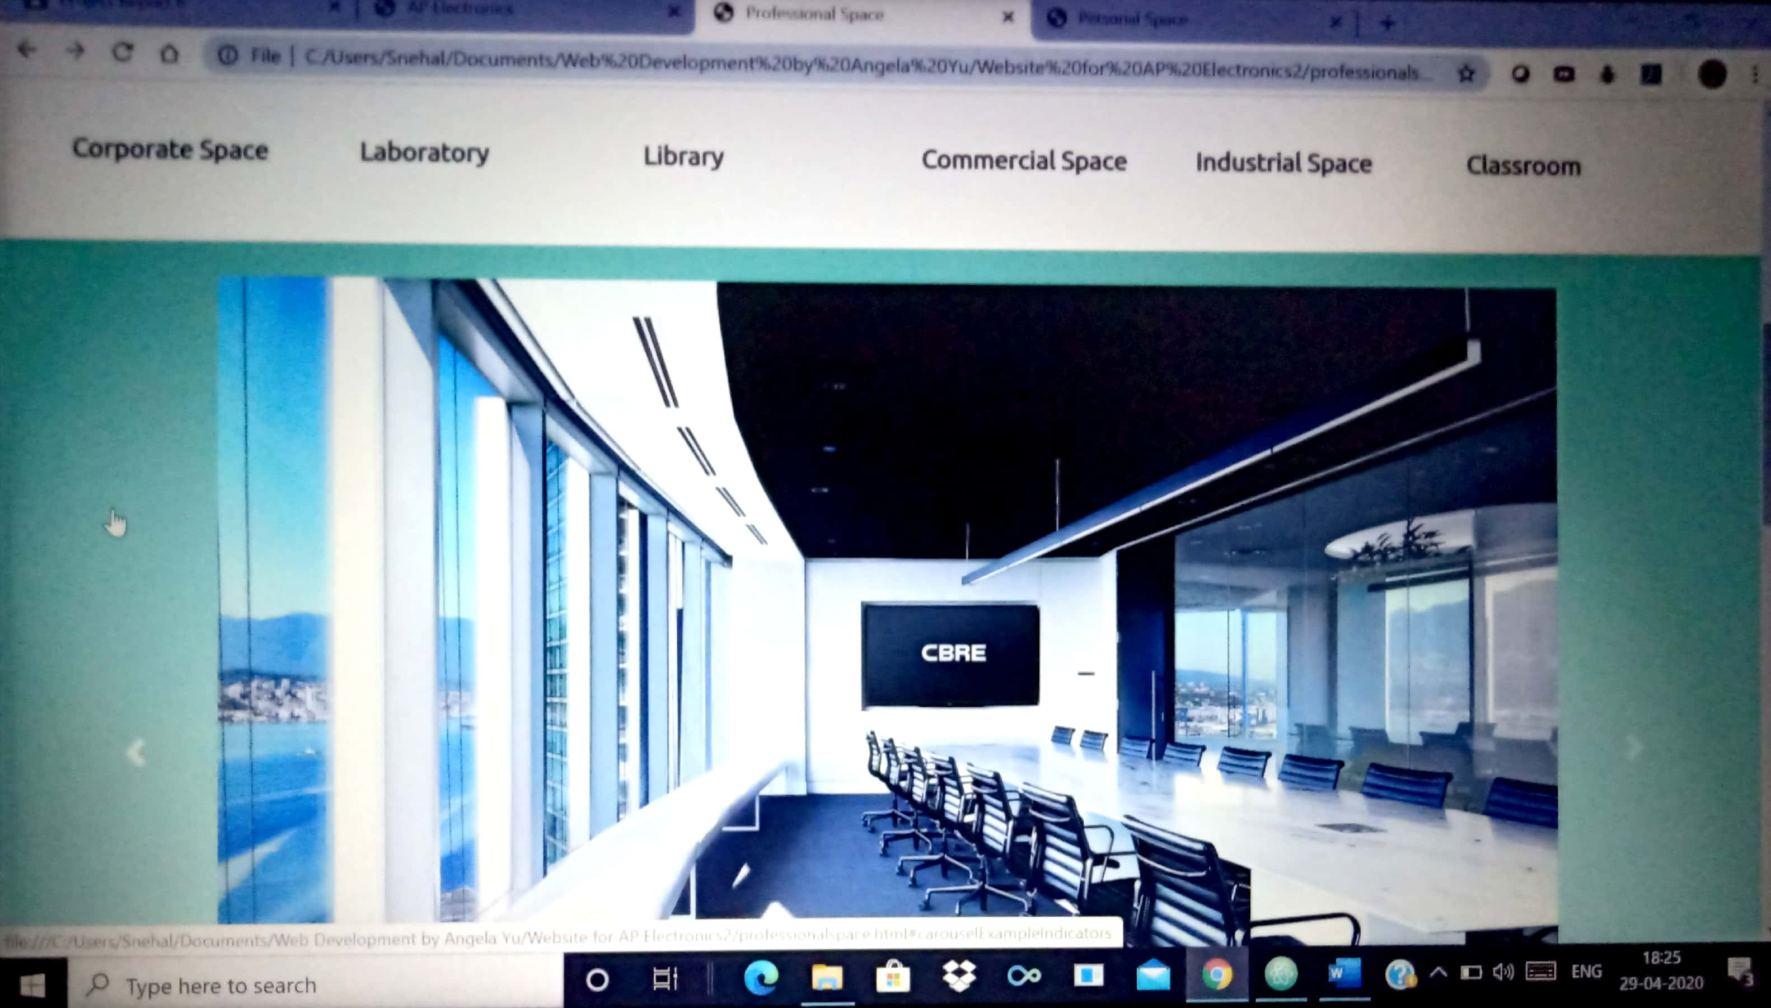

Image-11: Professional Space screenshot 2

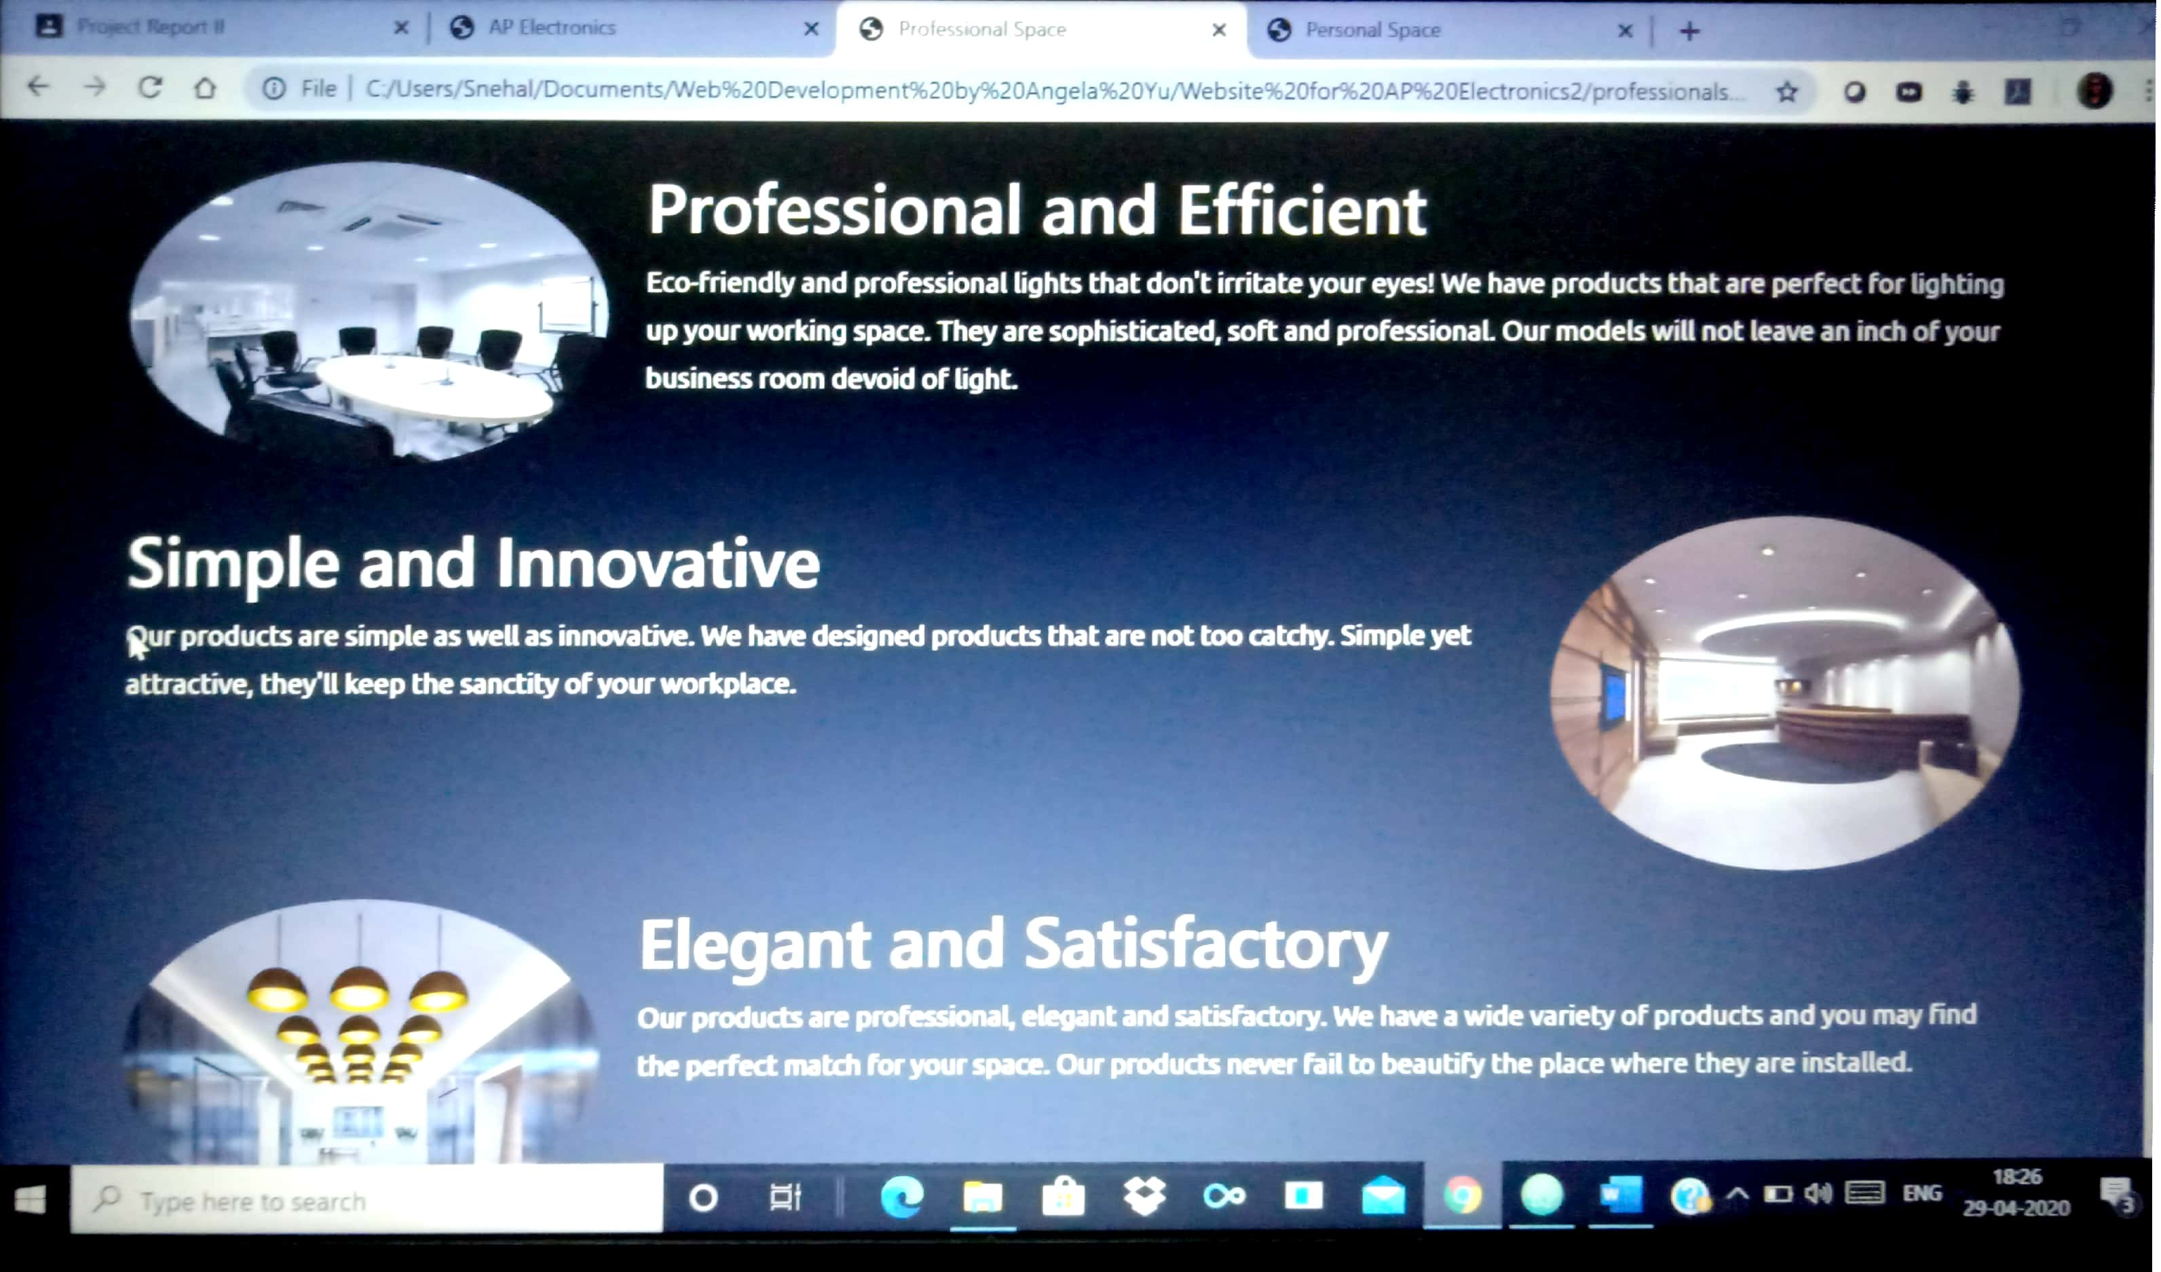

Image-12: Professional Space screenshot 3

# **back end development**

## **Database**

Back-end Development refers to the server-side development. It is the term used for the behind-the-scenes activities that happen when performing any action on a website. It can be logging in to an account or purchasing a product from an online store. Backend developer focuses on databases, scripting and the architecture of websites. Code written by back-end developers helps to communicate the database information to the browser.

The following images illustrate the process of developing the best set of relations needed to preserve the data pertaining to business transactions.

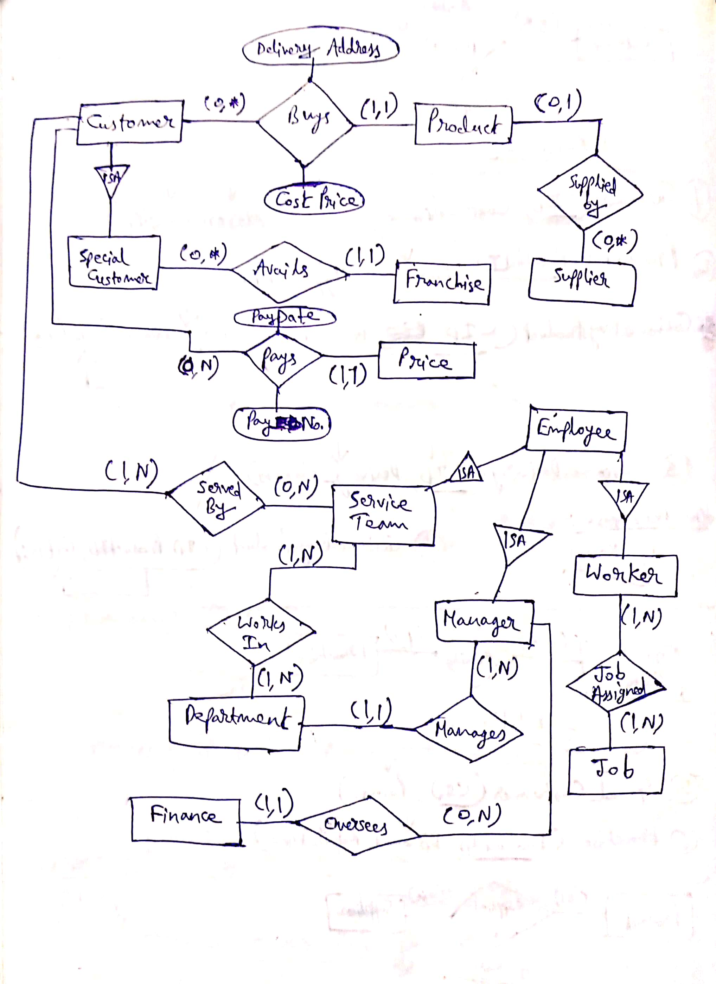

Image-13: Sketch of Entity Relationship Diagram

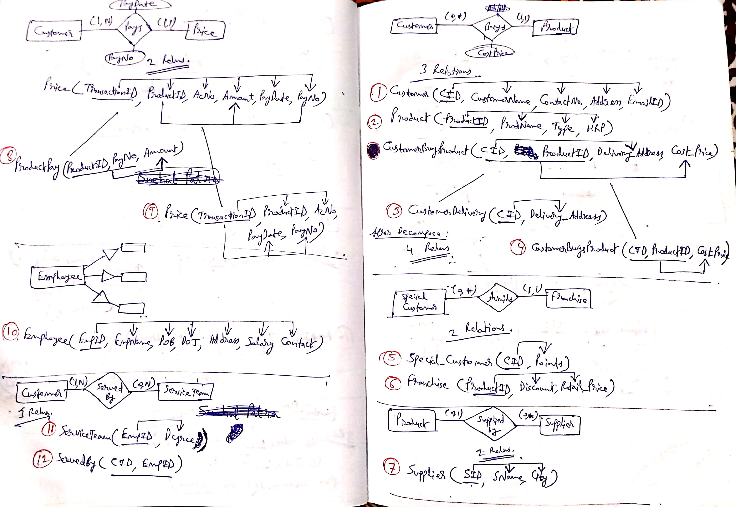

Image-14: Rough work on normalisation of relations

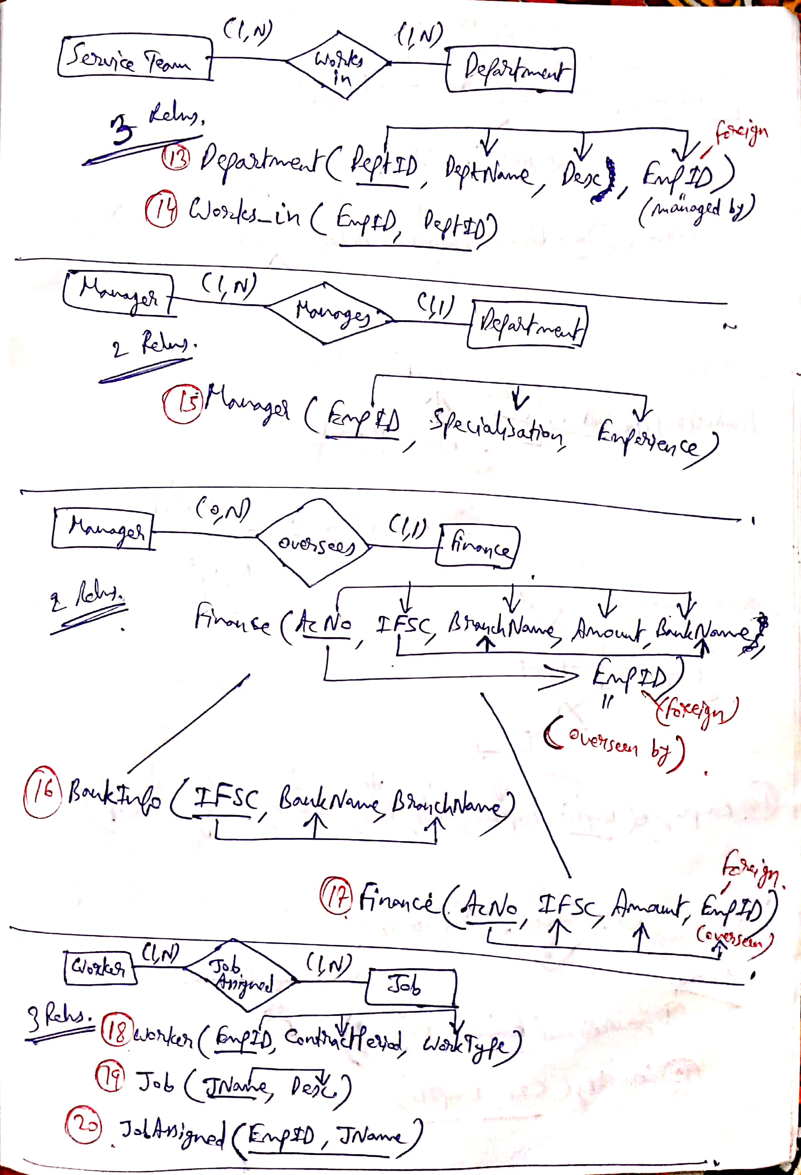

Image-15: Rough work on normalisation of relations

# **Entity relationship diagram**

An Entity Relationship Diagram gives a logical representation of the database. It is necessary for creation of an efficient relational model for the database. The relational model is the physical implementation of the Entity Relationship Diagram. The ER diagram (Entity Relationship Diagram) for the database that is to be maintained is given as follows:

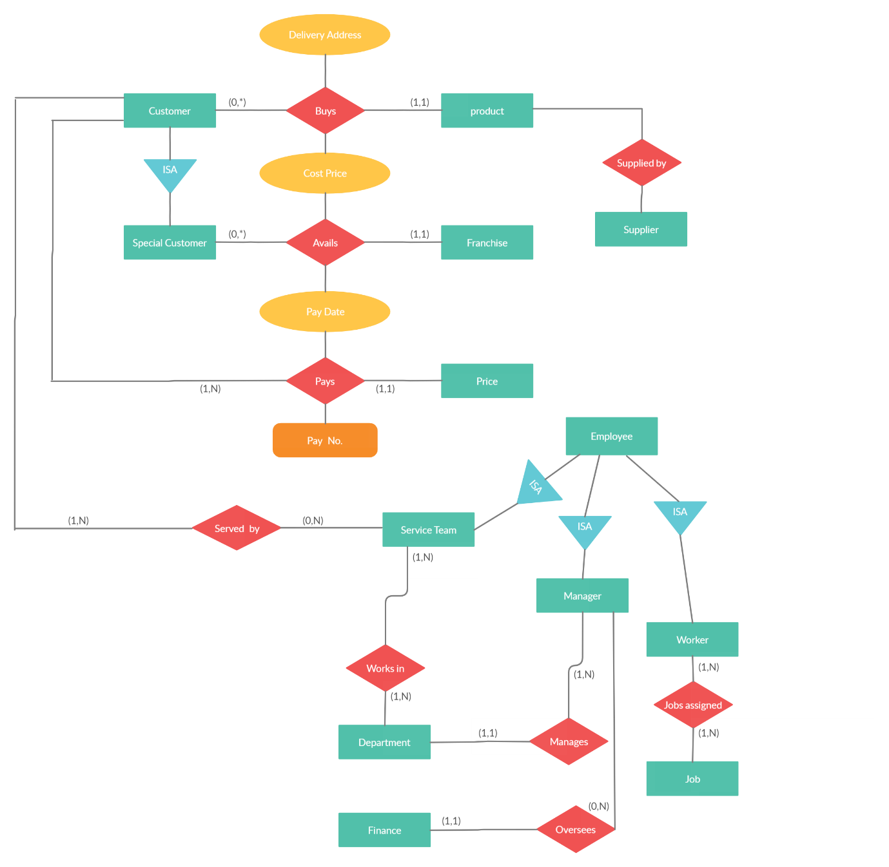

Image-16

## **Normalised Relations**

The relations have been normalised till BCNF (Boyce Codd Normal Form).

**Normalization** is the process of splitting relations into well-structured relations that allow users to insert, delete, and update tuples without introducing database. Without normalization many problems can occur when trying to load an integrated conceptual model into the DBSM. These problems arise from relations that are generated directly from user views are called anomalies. There are three types of anomalies: update, deletion and insertion anomalies.

**Anomaly due to insertion:** It is the inability to add data to a database due to the absence of other data.

**Anomaly due to update:** It is a data inconsistency that results from data redundancy and a partial update. If the user performing the update does not realise that the data is stored redundantly then the update will not be done properly.

**Anomaly due to deletion:** A deletion anomaly is the unintended loss of valuable data due to deletion of some other data.

There are **20 relations** in all. The normalised relations are as follows:

|  |  |
| --- | --- |
| Relation | Attributes |
| Customer | CID , CustomerName, ContactNo, Address, EmailID |
| Product | ProductID, ProdName, Type, MRP |
| CustomerDelivery | CID, Delivery_Address |
| CustomerBuysProduct | CID, ProductID, CostPrice |
| Special_Customer | CID, Points |
| Franchise | ProductID, Discount, Retail_Price |
| Supplier | SID, SName, City |
| ProductPay | ProductID, PayNo, Amount |
| Price | TransactionID, ProductID, AcNo, PayDate, PayNo |
| Employee | EmpID, EmpName, DOB, DOJ, Address, Salary, Contact |
| ServiceTeam | EmpID, Degree |
| ServedBy | CID, EmpID |
| Department | DeptID, DeptName, Desc, EmpID |
| Works_in | EmpID, DeptID |
| Manager | EmpID, Specialisation, Experience |
| BankInfo | IFSC, BankName, BranchName |
| Finance | AcNo, IFSC, Amount, EmpID |
| Worker | EmpID, ContactPeriod, WorkType |
| Job | JName, Desc |
| JobAssigned | EmpID, JName |

## **Database Server used: XAMPP**

**XAMPP** is a [free and open-source](https://en.wikipedia.org/wiki/Free_and_open-source) [cross-platform](https://en.wikipedia.org/wiki/Cross-platform) [web server](https://en.wikipedia.org/wiki/Web_server) [solution stack](https://en.wikipedia.org/wiki/Solution_stack) package developed by Apache Friends consisting mainly of the [Apache HTTP Server](https://en.wikipedia.org/wiki/Apache_HTTP_Server), [MariaDB](https://en.wikipedia.org/wiki/MariaDB) [database](https://en.wikipedia.org/wiki/Database), and [interpreters](https://en.wikipedia.org/wiki/Interpreter_(computing)) for scripts written in the [PHP](https://en.wikipedia.org/wiki/PHP) and [Perl](https://en.wikipedia.org/wiki/Perl) [programming languages](https://en.wikipedia.org/wiki/Programming_language).

XAMPP's ease of deployment means a [WAMP](https://en.wikipedia.org/wiki/WAMP) or [LAMP](https://en.wikipedia.org/wiki/LAMP_(software_bundle)) stack can be installed quickly and simply on an operating system by a developer, with the advantage that common add-in applications such as [WordPress](https://en.wikipedia.org/wiki/WordPress) and [Joomla!](https://en.wikipedia.org/wiki/Joomla!) can also be installed with similar ease using [**Bitnami**](https://en.wikipedia.org/wiki/Bitnami).

XAMPP is regularly updated to the latest releases of [Apache](https://en.wikipedia.org/wiki/Apache_HTTP_Server), [MariaDB](https://en.wikipedia.org/wiki/MariaDB), [PHP](https://en.wikipedia.org/wiki/PHP) and [Perl](https://en.wikipedia.org/wiki/Perl). It also comes with a number of other modules including [OpenSSL](https://en.wikipedia.org/wiki/OpenSSL), [phpMyAdmin](https://en.wikipedia.org/wiki/PhpMyAdmin), [MediaWiki](https://en.wikipedia.org/wiki/MediaWiki), [Joomla](https://en.wikipedia.org/wiki/Joomla), [WordPress](https://en.wikipedia.org/wiki/WordPress) and more. Self-contained, multiple instances of XAMPP can exist on a single computer, and any given instance can be copied from one computer to another. XAMPP is offered in both a full and a standard version.

The database has been successfully created in XAMPP and the work of back-end development is in progress.

# **snap shots of parts of the project**

Following are some of the screenshots of parts of the project :

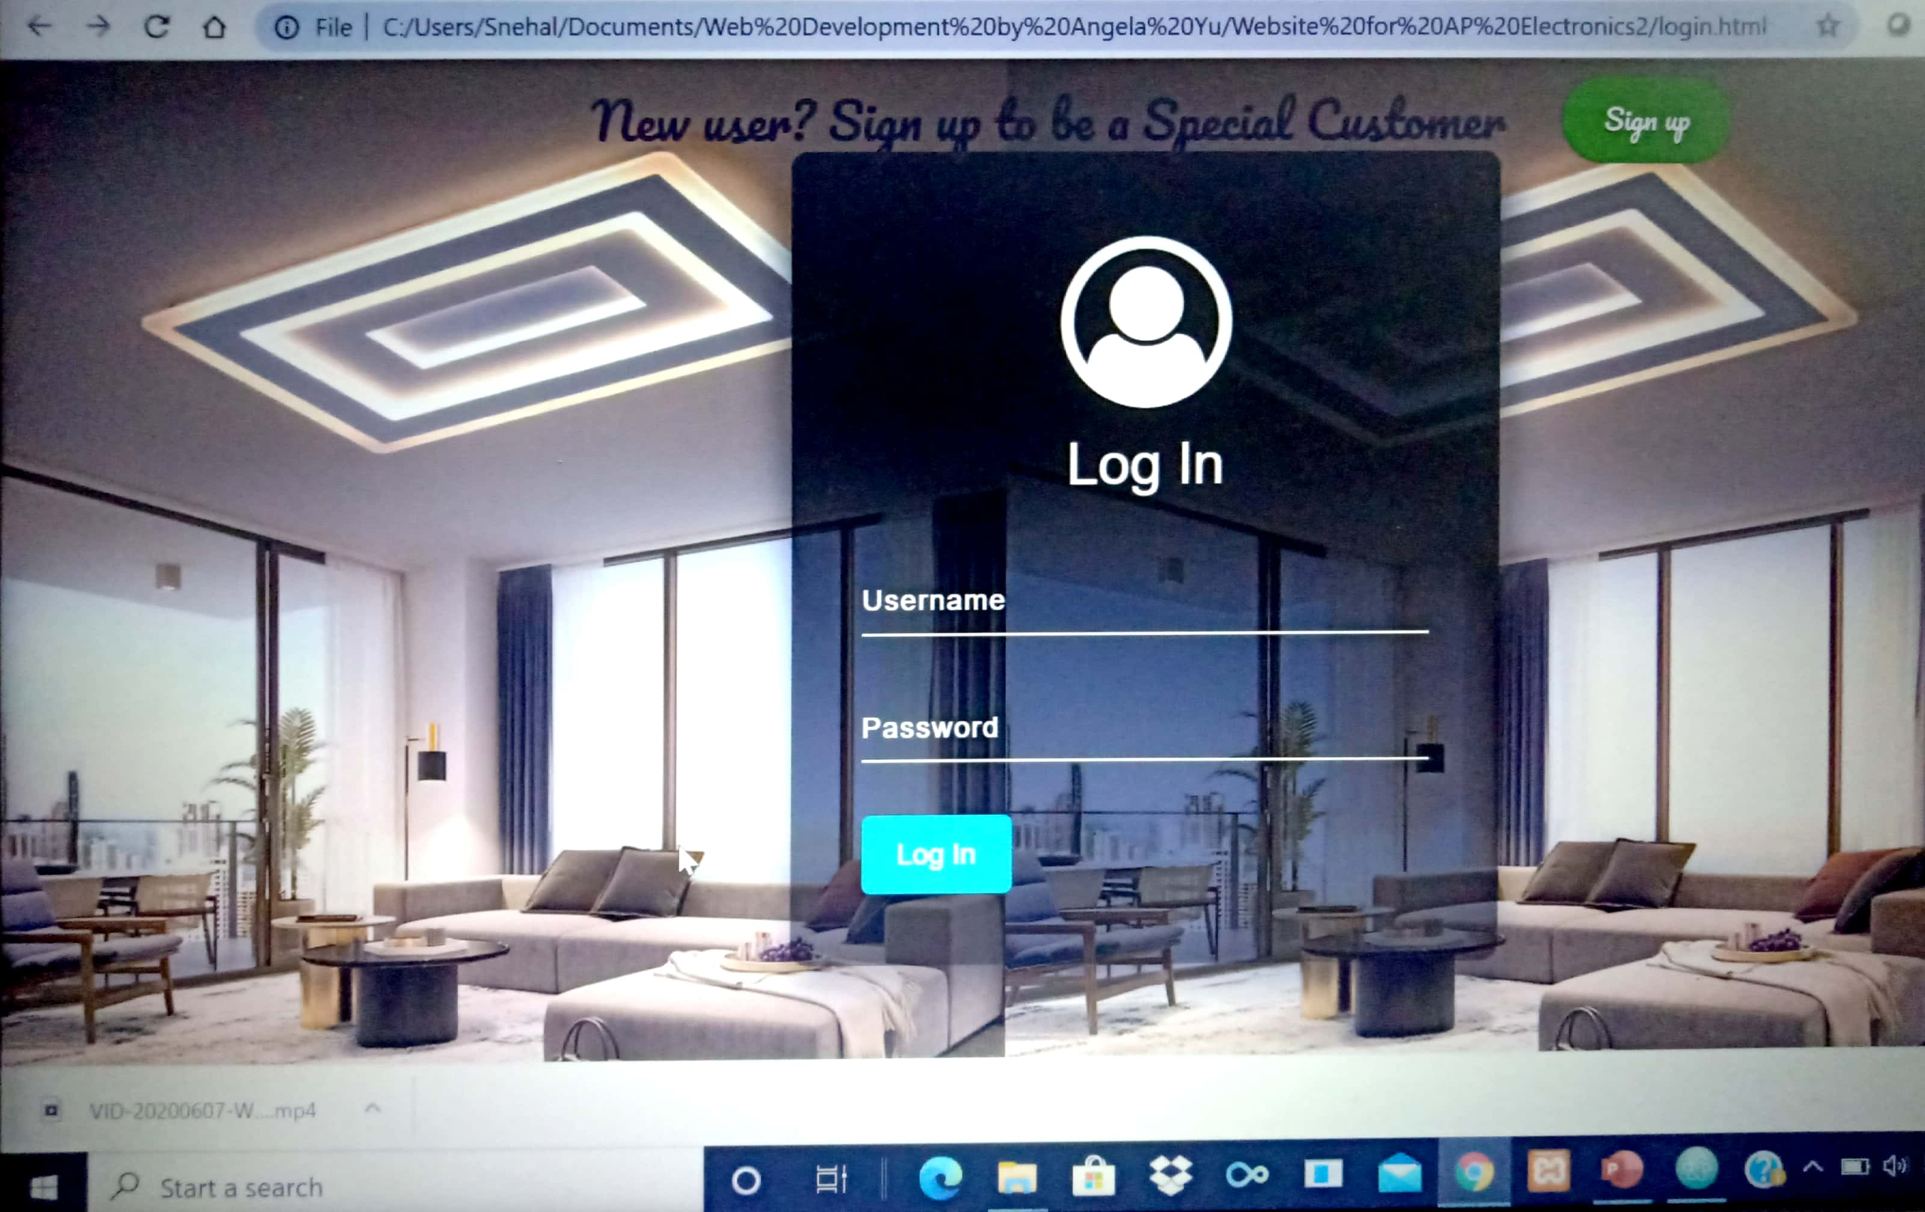

Image 17: Log in page

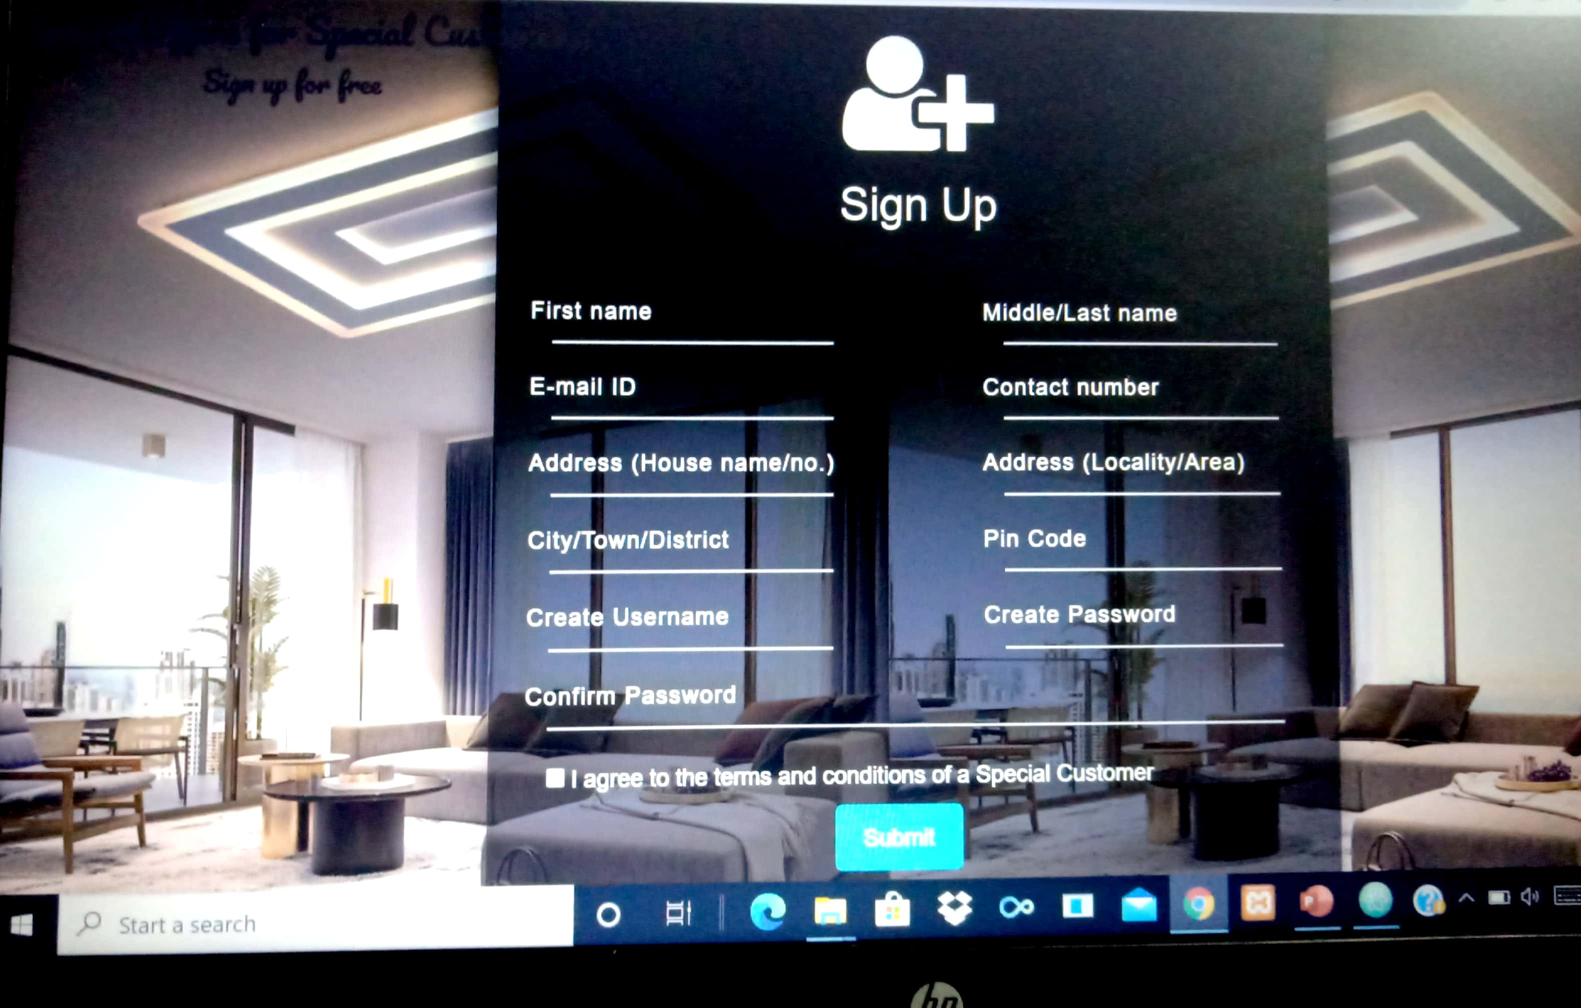

Image-18: Sign up page

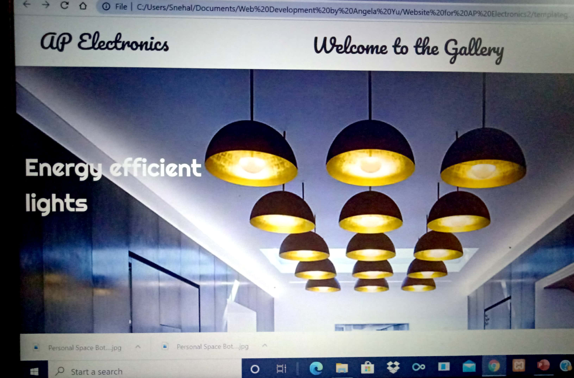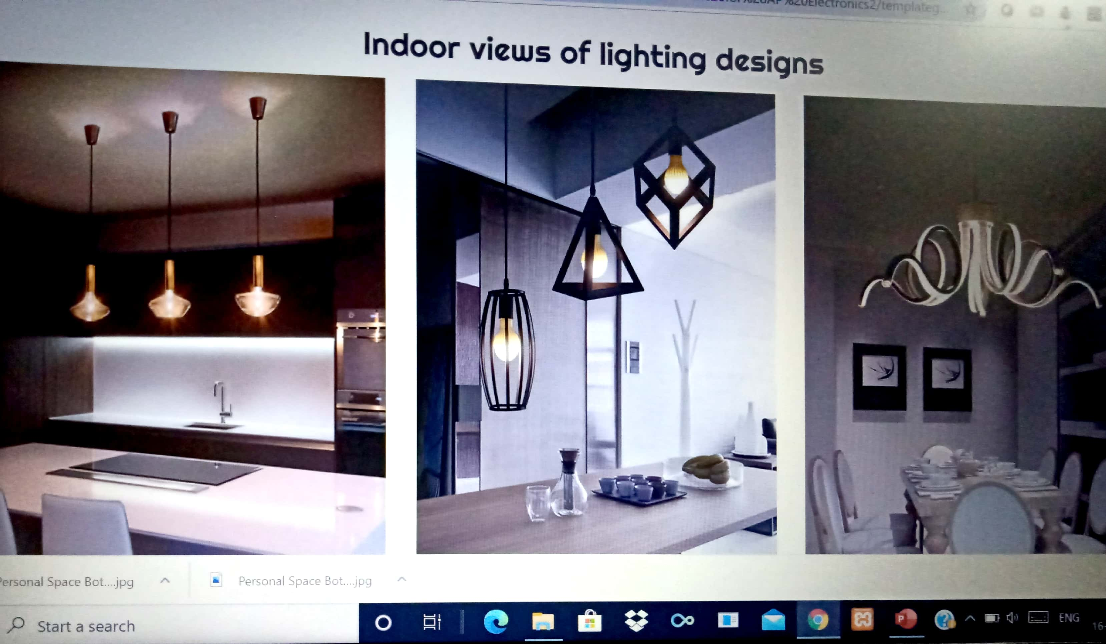

Images 19,20: Template Gallery

# **payment page**

A dummy payment page has been created whose layout is as follows:

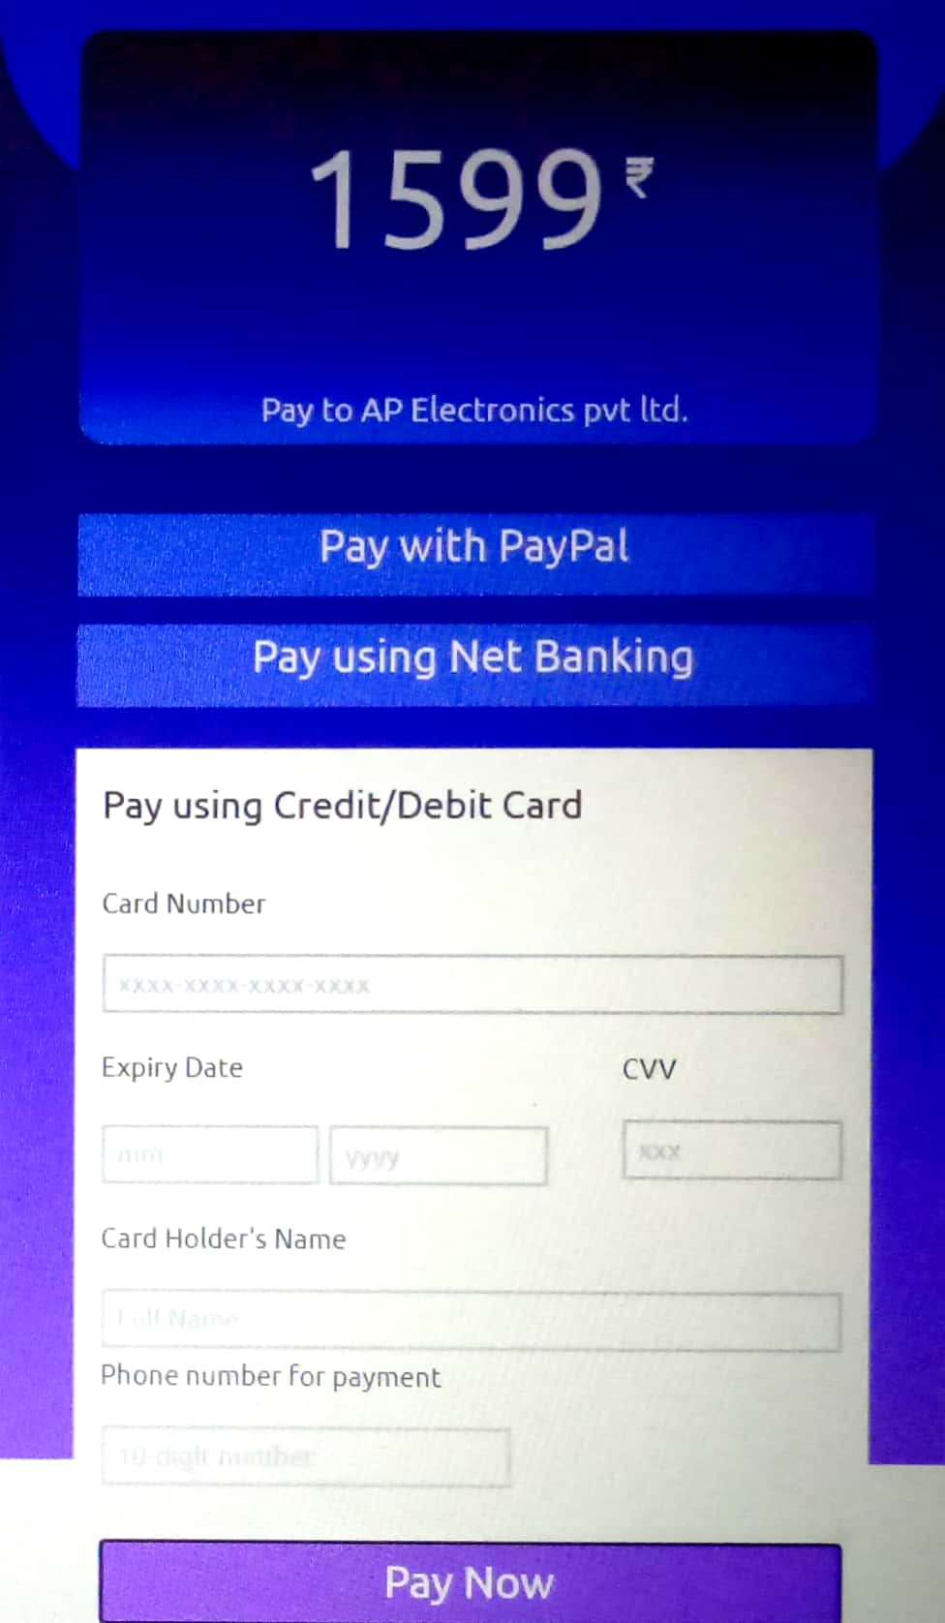

Image-21: Payment Page

# **conclusion**

The project has been implemented with as much perfection as possible. The project can be extended to be used for real-time business and is ready to be hosted on any web hosting server. A proper payment gateway and associated merchant need to be integrated to the existing project.

The project is ready to be used by any existing organisation for extension and integration for the purpose of real-time business needs.

# **reference**

The following references were made while implementing the project:

* Font Awesome: For pre-designed icons.
* Google fonts: For stylish fonts.
* Codepen.io: For trial execution of code snippets
* Bootstrap: For including features of interactive and responsive website.
* Dark Code: For model web pages and forms.
* Colorhunt.co: For hex-codes of wonderful shades of colours.

# **Appendix**

Feasibility analysis was carried out before starting the project. The five areas of project feasibility analysis are as follows:

* Technical feasibility
* Economic feasibility
* Legal feasibility
* Operational feasibility
* Scheduling feasibility

## **Technical feasibility**

The following needed technical supports are available:

**Text editor:** Atom-1.44.0

**Online platform for testing HTML/CSS/JS snippets:** codepen.io

**Operating system:** 64-bit Windows 10

**Processor:** Intel i3 @2.7GHz and above

**Database package:** XAMPP

## **Economic Feasibility**

Atom can be downloaded and installed for free. 'codepen.io’ provides an online platform for coding and testing HTML/CSS/JavaScript snippets where registration is free of cost. The cost for launching and maintaining the website needs to be met. Hosting of the website to be conducted by: **godaddy.com**

## **Legal Feasibility**

No functionality or term of service or technical utility goes against the law of the land. The website shall not be detrimental to the interests of any religion or community. The website shall not display any unethical or immoral content.

## **Operational Feasibility**

An operational feasibility study conducted revealed that the company is to benefit if it launches a website and expands its business online.

# **user manual**

* The user sees the home page upon loading the website.
* The user can sign up and be a prioritised customer.
* After successful sign up, the user can log in to the created account.
* The user can visit the template gallery by clicking on the template button.
* The user can visit specific areas such as ‘Personal Space’ or ‘Professional Space’ and go through product models of various categories.
* There is facility to order a product.
* The customer can go to the ‘Contact Us’ page to get in touch with the organisation.

# **developer manual**

A developer trying to develop a similar project needs to adopt the code similar to the one in the current project.

The developer may need the help of:

* Text editor: An efficient text editor like Atom or Sublime Text or Netbeans.
* Html, CSS or Javascript
* PHP for back end connectivity
* Testing submission of forms and data flow